**Add / Insert**

1) Run program

2) Input all new Media attributes

3) Click top menu “Insert”, or use short key “Alt+I”, the newly insert Media will be appended at the end of table.

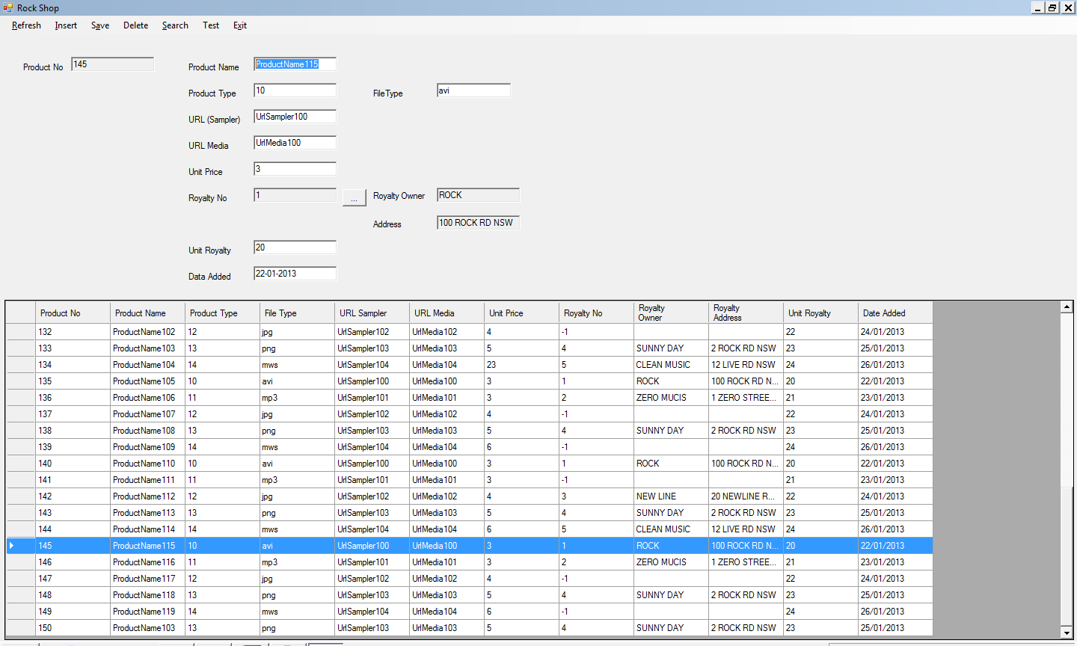

**Update**

1) Select any one Media record in Data Grid View

2) Input new values of relevant attributes Text Box

3) Click top menu “Save” or use short key “Alt-a”, to save all new attribute into system



**Delete/Remove**

1) Select any Media record from Data Grid View

2) Click top menu “Delete”

3) System will prompt you confirm your action by following confirmation box

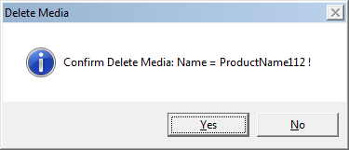

4) Once you click “Yes”, the Media record will be removed from system forever

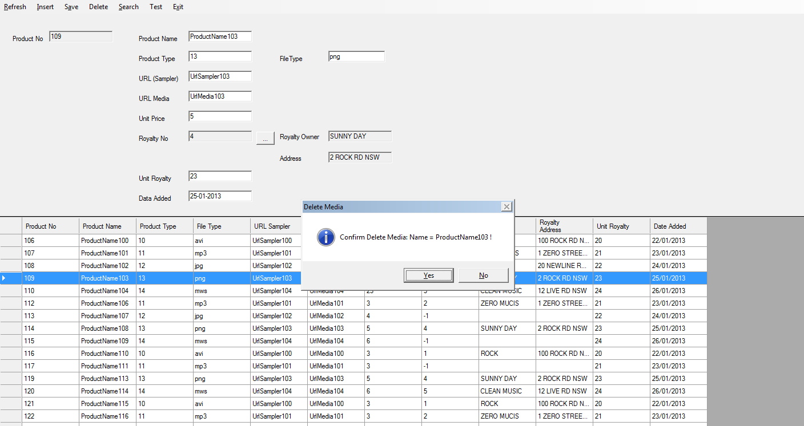

**Search**

1) Select any one Media as active Media, and change its Product Name (through the corresponding Text Field) to “ProductName”

2) You could set any attributes of Media as search conditions.

3) Select menu: search >> All Search, and you could get the results

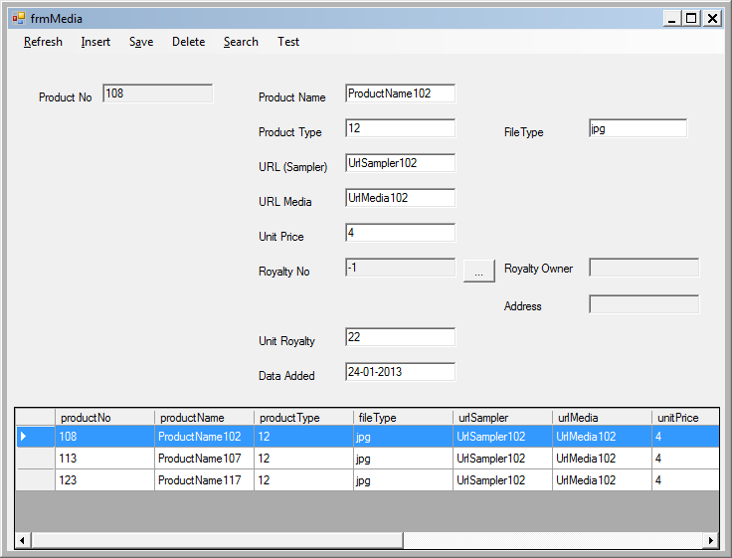

**Advanced Search**

1) Run program: Rockshop.exe

2) Input any characters you would like to search in any fields (For example, we just input “ProudctName” in Product Name text field, “Url” in URL text field, Unit Price is “3”, and royalty Owner is “ROCK”), and when the fields value are null, means the filter are not required

3) Click menu: Search, and select submenu: Adv Search

4) You could get the wildcard search result

